CS-76
BCA 6th Semester PROJECT

Bappaditya Ghosh

[ File Management System]

Table of Contents
Introduction of the Project: 4
Objective of the Project: 6
TOOLS/ENVIRONMENT USED: 7
Front End: 8
Google Spreadsheet Interface: 8
Programming Language (C#) : 9
DATABASE (MYSQL): 10
Analysis of the Project: 10
File Management System GUI: 11
View Manger: 11
File Management System Engine: 14
File System Watcher: 15
File Library manager: 16
File Security Controller: 16
File Backup Manager: 16
File Preview Generator: 16
File Upload Manager: 16
File Version Controller: 16
File Searching, Sorting & Filtering Manager: 16
GUI Interactor: 16
Database Manager: 16
File Management System Database: 17
Hardware & Software required for the application to run 17
Hardware Requirements 17
Software Requirements 17
Project Structure: 18
Project Estimation: 18
E-R Diagram: 20
Any Client/Industry: 22
Future Scope and Further enhancement of the project: 23

Introduction of the Project:
File management system provides a better way of organizing files in our computers. File management system will maintain extra information about the files so that users can easily access and use the file more efficiently. It will also help user to upload the files to online storage sites like Google Doc, Picasa, Scirbd, and Flickr.
With the advent new storage technology every computer is equipped with more and more storage space. We are having millions of files stored in our computer. But whenever we try to refer to a specific file we need to remember the file location. Most of the time users tend to forget the location or name of the file and spends lots of time searching it. File Management System facilitate the user to resolve all the existing issues.
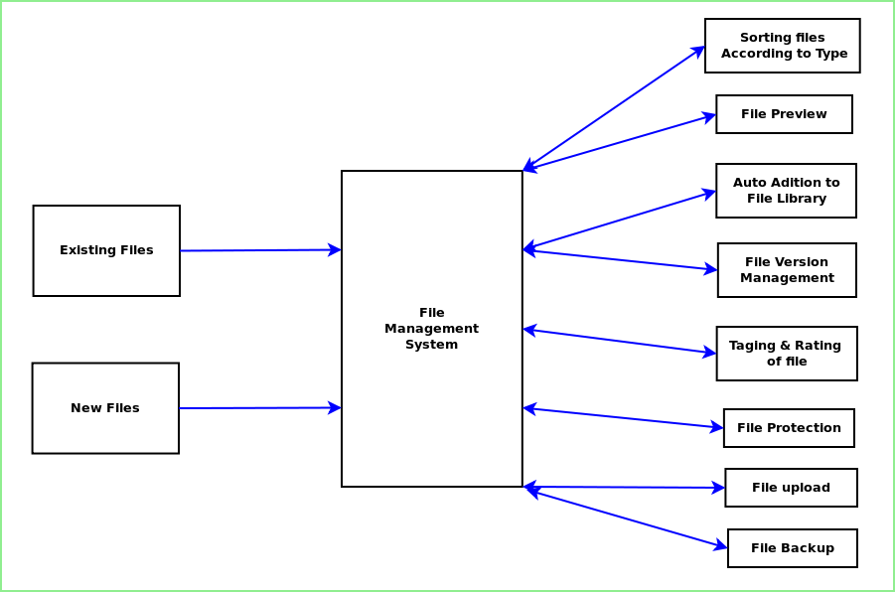
The below diagram display the overall features of File Management System.

The main feature set of File Management System is given below:
- Sorting the files according to type
- Preview files.
- Auto addition of existing & new files in the database.
- Duplicate file detection in the hard disk and optimizing & utilizing storage space.
- File version management, File revision history and change log.
- Associating search tags with a file for quick search.
- Associating Rating system with a file for quick access.
- Encrypting file and making it password protected.
- Uploading the file to online storage
  - File upload to Google Doc/ Esnips/ MediaFire
  - Photos upload to Picasa/ Flickr.
  - Video upload to Youtube
  - Multimedia Content Update to Social Networking Sites.
- Taking back up of important files in other drive or in online storage.

Objective of the Project:
The main objectives of the project are given below:
- Efficiently organise the files of Users PC and hard drive
- Provide standalone software for managing any kind of files.
- Quickly search and easily access the desired file
- Backing up important files locally and in web server.

TOOLS/ENVIRONMENT USED:
This software will follow Object Oriented Programming Paradigm and use below mentioned areas.
IDE USED (VISUAL STUDIO 2010 ):

Microsoft Visual Studio is a powerful IDE that ensures quality code throughout the entire application lifecycle, from design to deployment. Whether we are developing applications for SharePoint, the web, Windows, Windows Phone, and beyond, Visual Studio is the ultimate all-in-one solution. Visual Studio includes a code editor supporting IntelliSense as well as code refactoring. The integrated debugger works both as a source-level debugger and a machine-level debugger. Other built-in tools include a forms designer for building GUI applications, web designer, class designer, and database schema designer. It accepts plug-ins that enhance the functionality at almost every level—including adding support for source-control systems (like Subversion and Visual SourceSafe) and adding new toolsets like editors and visual designers for domain-specific languages or toolsets for other aspects of the software development lifecycle (like the Team Foundation Server client: Team Explorer).

Front End:

WPF (Windows Presentation Framework):
Windows Presentation Foundation (WPF) provides developers with a unified programming model for building rich Windows smart client user experiences that incorporate UI, media, and documents. Windows Presentation Foundation (WPF) is a next-generation presentation system for building Windows client applications with visually stunning user experiences. With WPF, you can create a wide range of both standalone and browser-hosted applications. The core of WPF is a resolution-independent and vector-based rendering engine that is built to take advantage of modern graphics hardware. WPF extends the core with a comprehensive set of application-development features that include Extensible Application Markup Language (XAML), controls, data binding, layout, 2-D and 3-D graphics, animation, styles, templates, documents, media, text, and typography. WPF is included in the Microsoft .NET Framework, so you can build applications that incorporate other elements of the .NET Framework class library.

Google Spreadsheet Interface:

With Google Spreadsheets, we can easily create, share, and edit spreadsheets online. Here are a few specific things we can do:
- Import and export these file types: .xls, .csv, .txt and .ods. We can also export data to a PDF or an HTML file.
- Format cells and edit formulas so we can calculate results and make data look the way we want it.
- Chat in real time with others who are editing our spreadsheet.
Embed a spreadsheet, or a section of a spreadsheet, in our blog or website.
Programming Framework (.NET 4):

The .NET 4 Framework is Microsoft's platform for building applications that have visually stunning user experiences, seamless and secure communication, and the ability to model a range of business processes. The .Net Framework consists of:
- Common Language Runtime – provides an abstraction layer over the operating system
- Base Class Libraries – pre-built code for common low-level programming tasks
- Development frameworks and technologies – reusable, customizable solutions for larger programming tasks.
The framework's Base Class Library provides user interface, data access, database connectivity, cryptography, web application development, numeric algorithms, and network communications. The class library is used by programmers, who combine it with their own code to produce applications.

Programming Language (C#) :
C# is a type-safe, object-oriented language that is simple yet powerful, allowing programmers to build a breadth of applications. C# is a multi-paradigm programming language encompassing imperative, declarative, functional, generic, object-oriented(class-based), and component-oriented programming disciplines. It was developed by Microsoft within the .NET initiative and later approved as a standard by Ecma (ECMA-334) and ISO (ISO/IEC 23270). C# is one of the programming languages designed for the Common Language Infrastructure.
C# is intended to be a simple, modern, general-purpose, object-oriented programming language.

DATABASE (MYSQL):
Internet Technologies:
HTML, JavaScript, PHP, Google App Framework
Operating Systems:
Windows XP, Windows 7
Applications:
PC Utility application
Supported File System:
NTFS, FAT

Analysis of the Project:
File Management System is divided into three main modules.
- GUI
- Engine
- Storage
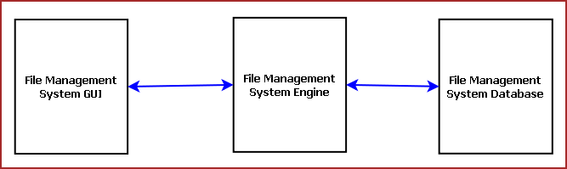

File Management System GUI:
File Management System GUI will display required information to the user and the user can navigate to different options from the GUI. The main components of GUI are:
- View Manager
- Main View
- Preview Window
- Navigator
- Common Controls
- Engine Interactor

View Manger:
View Manager controls the look and feel of the application. It manages the components of the GUI. View Manger keeps track of user preferences and displays the data according to it.
View Manager enables user to choose the view to be displayed and sort the data entries according to name, time etc.
Main View:
Main view displays the content of the file system. Main View can be represented as detailed view or thumbnail view.
In detailed view it will display file name, file path, modify date and many more configurable options.
In thumbnail view it will display the file name and thumbnail.
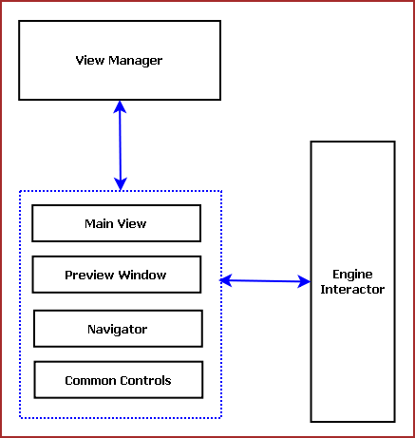
Fig: Components of File Management System GUI
Preview Window:
Preview window displays the preview of the currently selected file.
- Image: Image thumbnail
- PDF / Word Doc: Thumbnail of the first page
- Video: Thumbnail of first iFrame
- Music: Thumbnail of the artwork

Navigator:
Navigator helps user to navigate among different file types and specify filtering options for main view.
Common Controls:
Common controls include several controls of the application. Such as: Menu Bar, Toolbar, status bar, Context Menu and progress bar.
Engine Interaction:
This module handles the interaction between GUI and Engine. This module defines all callback for the Engine events.
The GUI layout of File Management System is shown below:

File Management System Engine:
File Management System Engine processes the User requests, saves info about files and always polls for file changes. It is mainly divided into following components:

- File System Watcher
- File Library manager
- File Security Controller
- File Backup Manager
- File Preview Generator
- File Upload Manager
- File Version Controller
- File Searching, Sorting & Filtering Manager
- GUI Interactor
- Database Manager
Different components of File Management System Engine and their interaction with other modules are displayed in the following diagram.
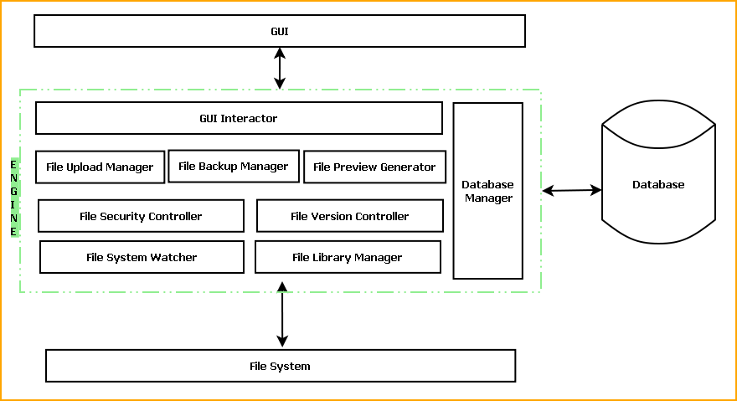

File System Watcher:
It is a windows service program which will run always in the system to track the changes in file system and record them for future reference.

File Library manager:
It maintains the list of files of different types. This adds new files and existing files into file library and passes the information about them to Database Manager.

File Security Controller:
It takes care of file security. It provides password protection. It encrypts and decrypts file on user request.

File Backup Manager:
It takes back up of user specified files depending on user preferences. File backup can be taken in a regular basis or on user request.

File Preview Generator:
This module generates the preview thumbnail for any file and saves them for future use. User may allow saving the thumbnails in database also for faster processing.

File Upload Manager:
This module uploads the file to online backup servers, social networking sites and online document websites.

File Version Controller:
This module keeps track of different versions of files. It allows comparing with previous versions, retrieval of previous version.

File Searching, Sorting & Filtering Manager:
This module takes care of File Searching, Sorting & Filtering.

GUI Interactor:
This module interacts with GUI module and serves GUI action request.

Database Manager:
This module manages the database. It handles information saving in database, retrieval of information from database.

File Management System Database:
File Management System Database will be an optimized database which will save certain information about every file available in the file system. We will use RDBMS concept.

Hardware & Software required for the application to run

Hardware Requirements
- Computer that has a 1.6GHz or faster processor
- 1 GB (32 Bit) or 2 GB (64 Bit) RAM
- 10 MB of available hard disk space
- DVD-ROM Drive / USB Port

Software Requirements
- Windows XP (x86) with Service Pack 3 / Windows Vista (x86) with Service Pack 2 / Windows 7 (x86)
- Microsoft .NET 4.0

E-R Diagram:
We will design a RDBMS for File Management System. The entities and their attributes are listed below. Attributes in Bold letter is the unique key.

Entities | Attributes
File | File Id, File Name, File Path, File Creation Time, Last Modify Time, Size, Type, Thumbnail, modifier user
Drive | Drive Id , Drive Name, Total Size , Occupied Size,
File System | File System Id, Type, Total Size , Occupied Size
User | User Id, Name, Social Network Data, password, Backup Path, Online Backup Path, Preferences.

Relationship between Entities:
- File System has Drives → 1 : N
- Drive has Files → 1 : N
- User uses File → M : N

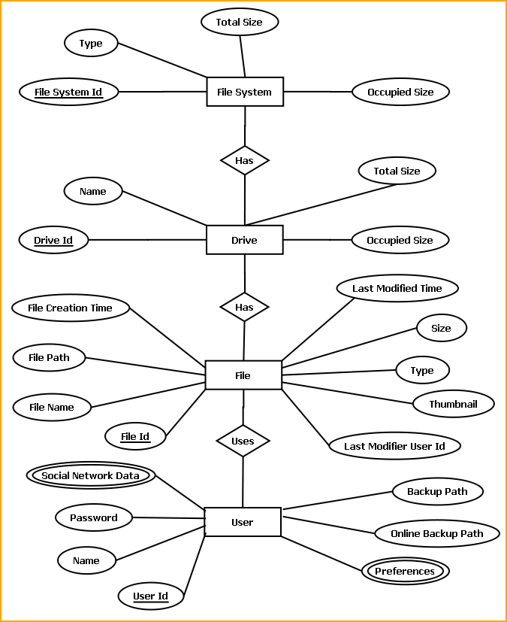
E-R Diagram of File Management System

Design Doc

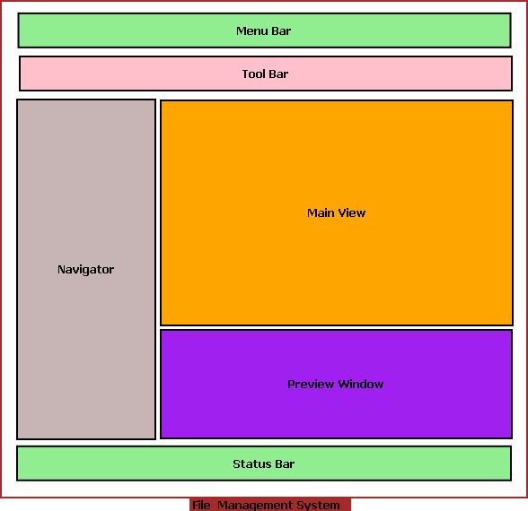

Menu bar contains the important features which can be accessed by shortcuts too. It is implemented using Menu control.
System.Windows.Controls.Menu
Namespace: System.Windows.Controls
Assembly: PresentationFramework (in PresentationFramework.dll)
Represents a Windows menu control that enables you to hierarchically organize elements associated with commands and event handlers.

Toolbar lists down the mostly used features. It is implemented using ToolBar control.
System.Windows.Controls.ToolBar
Namespace: System.Windows.Controls
Assembly: PresentationFramework (in PresentationFramework.dll)
Provides a container for a group of commands or controls.

Left navigation bar displays the tutorials available locally and online. This navigation bar is hide- able. It is implemented using the Expander control.
System.Windows.Controls.Expander
Namespace: System.Windows.Controls
Assembly: PresentationFramework (in PresentationFramework.dll)
Represents the control that displays a header that has a collapsible window that displays content.

The local contents are displayed in a TreeView control. And every contents are displayed in in a TreeViewItem.
System.Windows.Controls.TreeView
Namespace: System.Windows.Controls
Assembly: PresentationFramework (in PresentationFramework.dll)
Represents a control that displays hierarchical data in a tree structure that has items that can expand and collapse.

Online contents are displayed in a WebBrowser control. Users can select the content and purchase it from there.
System.Windows.Controls.WebBrowser
Namespace: System.Windows.Controls
Assembly: PresentationFramework (in PresentationFramework.dll)
Hosts and navigates between HTML documents. Enables interoperability between WPF managed code and HTML script.

Textpane displays the Texts. This is implemented using a TextBlock control.
System.Windows.Controls.TextBlock
Namespace: System.Windows.Controls
Assembly: PresentationFramework (in PresentationFramework.dll)
Provides a lightweight control for displaying small amounts of flow content.

Video and audio playing is implemented using MediaElement control.
System.Windows.Controls.MediaElement
Namespace: System.Windows.Controls
Assembly: PresentationFramework (in PresentationFramework.dll)
Represents a control that contains audio and/or video.

Images are displayed using Image control.
System.Windows.Controls.Image
Namespace: System.Windows.Controls
Assembly: PresentationFramework (in PresentationFramework.dll)
Represents a control that displays an image.

Drawing pane is implemented using InkCanvas control.
System.Windows.Controls.InkCanvas
Namespace: System.Windows.Controls
Assembly: PresentationFramework (in PresentationFramework.dll)
Defines an area that receives and displays ink strokes.

Statusbar displays the information about the application and the tutorial currently running. Its implemented using StatusBar Class.
System.Windows.Controls.Primitives.StatusBar
Namespace: System.Windows.Controls.Primitives
Assembly: PresentationFramework (in PresentationFramework.dll)
Represents a control that displays items and information in a horizontal bar in an application window.

Engine Design:

Reading & Writing XML:
In this application the tutorials are saved as XML file. The application will process the XML and play the tutorial. So we have implemented XML reader and writer logic. XML operations are done using .NET XML parser. Every XML element is represented as a XElement control.
System.Xml.Linq.XElement
Namespace: System.Xml.Linq
Assembly: System.Xml.Linq (in System.Xml.Linq.dll)
Represents an XML element.

Installer
This software is packaged using Visual studio Installer utility. It provides a MSI file to be installed on end user side.
This installer will include all the required DLL to run this software
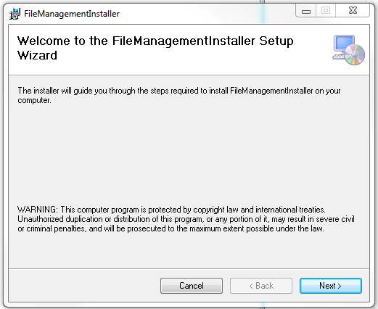
The users can browse the installation folder for this software and install the software in the desired path.

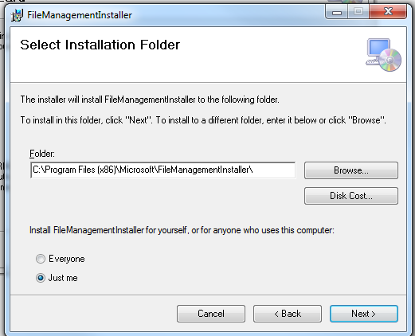
It will take some time to install the software in the PC and create shortcut icons on Desktop and program menus.

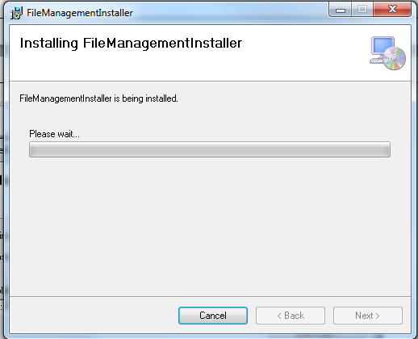

Program code

GUI CODE
MainWindow.xaml
<Window x:Class="FileManagementSystem.MainWindow"
xmlns="http://schemas.microsoft.com/winfx/2006/xaml/presentation"
xmlns:x="http://schemas.microsoft.com/winfx/2006/xaml"
Title="File Management System" Height="600" Width="800">
<DockPanel LastChildFill="True">
<Menu DockPanel.Dock="Top">
<MenuItem Header="file">
<MenuItem Header="Create Library" Name="createLibMenuItem" Click="createLibMenuItem_Click"></MenuItem>
<MenuItem Header="open"></MenuItem>
<MenuItem Header="save"></MenuItem>
<MenuItem Header="save as"></MenuItem>
</MenuItem>
<MenuItem Header="view">
<MenuItem Header="full screen"></MenuItem>
<MenuItem Header="tool box"></MenuItem>
</MenuItem>
<MenuItem Header="edit">
<MenuItem Header="copy"></MenuItem>
<MenuItem Header="cut"></MenuItem>
<MenuItem Header="undo"></MenuItem>
<MenuItem Header="redo"></MenuItem>
</MenuItem>
<MenuItem Header="help">
<MenuItem Header="view help"></MenuItem>
</MenuItem>
<MenuItem Header="tools">
<MenuItem Header="connect to data base"></MenuItem>
<MenuItem Header="connect to server"></MenuItem>
<MenuItem Header="mocros"></MenuItem>
</MenuItem>
<MenuItem Header="window">
<MenuItem Header="close all document"></MenuItem>
<MenuItem Header="hide"></MenuItem>
<MenuItem Header="auto hide"></MenuItem>

</MenuItem>
<Separator></Separator>
</Menu>
<ToolBar DockPanel.Dock="Top">
<Button Click="createLibMenuItem_Click">Create Library</Button>
<Separator></Separator>
<Button Name="importLibBtn" Click="importLibBtn_Click">Import Library</Button>
<Separator></Separator>
<Button Name="backupBtn" Click="backupBtn_Click">Backup</Button>
<Separator></Separator>
<Button>Refresh Library</Button>
<Separator></Separator>
<Button>Starred</Button>
<Separator></Separator>
<TextBox Background="Azure" Width="150" HorizontalContentAlignment="Center">Search files</TextBox>
<Separator></Separator>
<Button>Settings</Button>
<Separator></Separator>
<Button>Upload to Web</Button>
</ToolBar>
<StatusBar DockPanel.Dock="Bottom">
<Label>No files selected</Label>
<ProgressBar Width="200" Height="20"></ProgressBar>
</StatusBar>
<DockPanel DockPanel.Dock="Bottom">
<DockPanel Name="navigatorSideBar" DockPanel.Dock="Left" Width="200" Background="#FFF2D9D9"></DockPanel>
<TextBlock Height="200" DockPanel.Dock="Bottom" Name="informationBrowserTB" Background="#FFB8EBB8">Information Browser</TextBlock>
<ListView Name="mainView" DockPanel.Dock="Top"></ListView>
</DockPanel>
</DockPanel>
</Window>

MainWindow.xaml.cs
using System;
using System.Collections.Generic;
using System.Linq;
using System.Text;
using System.Windows;
using System.Windows.Controls;
using System.Windows.Data;
using System.Windows.Documents;
using System.Windows.Input;
using System.Windows.Media;
using System.Windows.Media.Imaging;
using System.Windows.Navigation;
using System.Windows.Shapes;

namespace FileManagementSystem
{
/// <summary>
/// Interaction logic for MainWindow.xaml
/// </summary>
public partial class MainWindow : Window
{
public MainWindow()
{
InitializeComponent();
}

private void createLibMenuItem_Click(object sender, RoutedEventArgs e)
{
CreateLibrary cl = new CreateLibrary();
cl.ShowDialog();
}

private void importLibBtn_Click(object sender, RoutedEventArgs e)
{
Microsoft.Win32.OpenFileDialog ofd = new Microsoft.Win32.OpenFileDialog();

if (ofd.ShowDialog() == true)
{

}
}

private void backupBtn_Click(object sender, RoutedEventArgs e)
{

}
}
}
CreateLibrary.xaml
<Window x:Class="FileManagementSystem.CreateLibrary"
xmlns="http://schemas.microsoft.com/winfx/2006/xaml/presentation"
xmlns:x="http://schemas.microsoft.com/winfx/2006/xaml"
Title="Create Library" Height="265" Width="542">
<Grid>
<Label Content="Name" Height="28" HorizontalAlignment="Left" Margin="38,40,0,0" Name="label1" VerticalAlignment="Top" />
<TextBox Height="23" HorizontalAlignment="Left" Margin="108,44,0,0" Name="textBox1" VerticalAlignment="Top" Width="255" />
<Label Content="Path" Height="28" HorizontalAlignment="Left" Margin="46,104,0,0" Name="label2" VerticalAlignment="Top" />
<TextBox Height="23" HorizontalAlignment="Left" Margin="108,104,0,0" Name="textBox2" VerticalAlignment="Top" Width="255" />
<Button Content="Browse" Height="23" HorizontalAlignment="Left" Margin="395,104,0,0" Name="browseBtn" VerticalAlignment="Top" Width="75" Click="browseBtn_Click" />
<Button Content="Create" Height="34" HorizontalAlignment="Left" Margin="85,170,0,0" Name="createBtn" VerticalAlignment="Top" Width="155" Click="createBtn_Click" />
<Button Content="Cancel" Height="34" HorizontalAlignment="Left" Margin="315,170,0,0" Name="cancelBtn" VerticalAlignment="Top" Width="155" Click="cancelBtn_Click" />
</Grid>
</Window>

Upload to Web
/* Copyright (c) 2007 Google Inc.
*
* Licensed under the Apache License, Version 2.0 (the "License");
* you may not use this file except in compliance with the License.
* You may obtain a copy of the License at
*
* http://www.apache.org/licenses/LICENSE-2.0
*
* Unless required by applicable law or agreed to in writing, software
* distributed under the License is distributed on an "AS IS" BASIS,
* WITHOUT WARRANTIES OR CONDITIONS OF ANY KIND, either express or implied.
* See the License for the specific language governing permissions and
* limitations under the License.
*/

using System;
using System.Collections.Generic;
using System.ComponentModel;
using System.Data;
using System.Drawing;
using System.Diagnostics;
using System.Text;
using System.Windows.Forms;
using Google.GData.Client;
using Google.GData.Documents;

namespace DocListUploader
{
public partial class OptionsForm : Form
{
private bool lastToolTipWasUpload = false;
public bool loggedIn = false;
private string file = "c:\\testfile.txt";
private DocumentsService service;
private DocumentEntry lastUploadEntry = null;
/// <summary>
/// Constructor for the OptionsForm.
/// </summary>
/// <param name="mainForm">The parent form that created this one.</param>
public OptionsForm()
{
InitializeComponent();
}

private void LoginButton_Click(object sender, EventArgs e)
{
if (Username.Text == "")
{
MessageBox.Show("Please specify a username", "No user name", MessageBoxButtons.OK, MessageBoxIcon.Error);
return;
}
if (Password.Text == "")
{
MessageBox.Show("Please specify a password", "No password", MessageBoxButtons.OK, MessageBoxIcon.Error);
return;
}

try
{
LoginButton.Text = "Logging In";

LoginButton.Enabled = false;
LogoutButton.Enabled = true;

Username.Enabled = false;
Password.Enabled = false;
Login(Username.Text, Password.Text);
LoginButton.Text = "Logged In";

}
catch (Exception ex)
{
LoginButton.Enabled = true;
LogoutButton.Enabled = false;
Username.Enabled = true;
Password.Enabled = true;

LoginButton.Text = "Login";

MessageBox.Show("Error logging into Google Docs: " + ex.Message, "Login Error", MessageBoxButtons.OK, MessageBoxIcon.Error);
}
}

private void Username_KeyPress(object sender, KeyPressEventArgs e)
{
//If the user hits enter, skip to the next field.
if (e.KeyChar == (char) 13)
{
Password.Focus();
}
}

/// <summary>
/// Authenticates to Google servers
/// </summary>
/// <param name="username">The user's username (e-mail)</param>
/// <param name="password">The user's password</param>
/// <exception cref="AuthenticationException">Thrown on invalid credentials.</exception>
public void Login(string username, string password)
{
if (loggedIn)
{
throw new ApplicationException("Already logged in.");
}
try
{
service = new DocumentsService("DocListUploader");
((GDataRequestFactory)service.RequestFactory).KeepAlive = false;
service.setUserCredentials(username, password);
//force the service to authenticate
DocumentsListQuery query = new DocumentsListQuery();
query.NumberToRetrieve = 1;
service.Query(query);
loggedIn = true;
}
catch (AuthenticationException e)
{
loggedIn = false;
service = null;
throw e;
}
}

/// <summary>
/// Logs the user out of Google Docs.
/// </summary>
public void Logout()
{
loggedIn = false;
service = null;
}

/// <summary>
/// Some error handling around the file upload method. Used for handling files from the context menu.
/// </summary>
/// <param name="file">The file to upload.</param>
public void HandleUpload(string file)
{
if (!loggedIn)
{
MessageBox.Show("Please log in before uploading documents", "Upload Error", MessageBoxButtons.OK, MessageBoxIcon.Error);
return;
}
try
{
lastToolTipWasUpload = false;
UploadFile(file);
lastToolTipWasUpload = true;

}
catch (ArgumentException)
{
//DocListNotifyIcon.ShowBalloonTip(BALLOON_TIMER, "Upload Error", "Error: unable to upload the file: '" + file + "'. It is not one of the valid types.", ToolTipIcon.Error);
lastToolTipWasUpload = false;
}
catch (Exception ex)
{
//DocListNotifyIcon.ShowBalloonTip(BALLOON_TIMER, "Upload Error", "Error: unable to upload the file: '" + file + "'. " + ex.Message, ToolTipIcon.Error);
lastToolTipWasUpload = false;
}
}

/// <summary>
/// Uploads the file to Google Docs
/// </summary>
/// <param name="fileName">The file with path to upload</param>
/// <exception cref="ApplicationException">Thrown when user isn't logged in.</exception>
public void UploadFile(string fileName)
{
if (!loggedIn)
{
throw new ApplicationException("Need to be logged in to upload documents.");
}
else
{
lastUploadEntry = service.UploadDocument(fileName, null);
}
}

private void Password_KeyPress(object sender, KeyPressEventArgs e)
{
//If the user hits enter, try to log in.
if (e.KeyChar == (char) 13)
{
LoginButton_Click(null, null);
}
}

private void button1_Click(object sender, EventArgs e)
{
if (!mainForm.loggedIn)
{
MessageBox.Show("Please log in before uploading documents", "Upload Error", MessageBoxButtons.OK, MessageBoxIcon.Error);
return;
}

try
{
statusLabel.Text = "Uploading " + file;
this.Refresh();
mainForm.UploadFile(file);
statusLabel.Text = "Successfully uploaded " + file;

}
catch (ArgumentException)
{
DialogResult result = MessageBox.Show("Error, unable to upload the file: '" + file + "'. It is not one of the valid types.", "Upload Error", MessageBoxButtons.OKCancel, MessageBoxIcon.Error);
statusLabel.Text = "Problems uploading";
if (result == DialogResult.Cancel)
{
return;
}
}
catch (Exception ex)
{
DialogResult result = MessageBox.Show("Error, unable to upload the file: '" + file + "'. " + ex.Message, "Upload Error", MessageBoxButtons.OKCancel, MessageBoxIcon.Error);
statusLabel.Text = "Problems uploading";
if (result == DialogResult.Cancel)
{
return;
}
}
}

private void LogoutButton_Click(object sender, EventArgs e)
{
mainForm.Logout();
LoginButton.Enabled = true;
LogoutButton.Enabled = false;
Username.Enabled = true;
Password.Enabled = true;
LoginButton.Text = "Login";
}
}
}
/* Copyright (c) 2007 Google Inc.
*
* Licensed under the Apache License, Version 2.0 (the "License");
* you may not use this file except in compliance with the License.
* You may obtain a copy of the License at
*
* http://www.apache.org/licenses/LICENSE-2.0
*
* Unless required by applicable law or agreed to in writing, software
* distributed under the License is distributed on an "AS IS" BASIS,
* WITHOUT WARRANTIES OR CONDITIONS OF ANY KIND, either express or implied.
* See the License for the specific language governing permissions and
* limitations under the License.
*/

using System;
using System.Collections.Generic;
using System.ComponentModel;
using System.Data;
using System.Drawing;
using System.Diagnostics;
using System.IO;
using System.Text;
using System.Windows.Forms;
using System.Threading;
using System.Runtime.Remoting;
using System.Runtime.Remoting.Channels;
using System.Runtime.Remoting.Channels.Ipc;
using Microsoft.Win32;
using Google.GData.Documents;
using Google.GData.Client;

namespace DocListUploader
{
/// <summary>
/// The main form of the uploader, controls most of the service interaction.
/// It is not actually displayed to the user.
/// </summary>
public partial class HiddenForm : Form
{
//A child form for the user to interact with.
private OptionsForm optionsForm;
//Keeps track of our logged in state.

//A connection with the DocList API.

//The name of the shell context menu option.
private const string KEY_NAME = "Send to Google Docs";
//Keeps track of if we've minimized the OptionsForm before.
private bool firstMinimize = true;
//The timer in milliseconds to display balloon tips.
private const int BALLOON_TIMER = 10000;
//The most recently uploaded document.

//Keeps track of if the last balloon tip was an upload complete message.

/// <summary>
/// Constructor for the form.
/// </summary>
public HiddenForm()
{
InitializeComponent();
optionsForm = new OptionsForm(this);
ListenForSuccessor();
}

/// <summary>
/// The main entry point for the application.
/// </summary>
[STAThread]
static void Main(string[] args)
{
bool firstInstance;
Mutex mutex = new Mutex(true, "Local\\DocListUploader", out firstInstance);
if (!firstInstance)
{
//If we have an argument, we were most likely called by
//the shell context menu
if (args.Length == 1)
{
NotifyPredecessor(args[0]);
}
return;
}
Application.EnableVisualStyles();
Application.SetCompatibleTextRenderingDefault(false);
Application.Run(new HiddenForm());
}

/// <summary>
/// This is run by the first instance of the program in order
/// to accept information from later instances using the
/// .NET Framework's IPC mechanism.
/// </summary>
public void ListenForSuccessor()
{
IpcServerChannel serverChannel = new IpcServerChannel("DocListUploader");
ChannelServices.RegisterChannel(serverChannel, false);

RemoteMessage remoteMessage = new RemoteMessage(this);
RemotingServices.Marshal(remoteMessage,"FirstInstance");

}

/// <summary>
/// This is used by later instances of the program when
/// executed from the shell's context menu to pass along
/// the path of a file that will be uploaded. This message
/// is passed using the .NET Framework's IPC mechanism.
/// </summary>
/// <param name="file">The file to be uploaded</param>
public static void NotifyPredecessor(string file)
{
IpcClientChannel clientChannel = new IpcClientChannel();
ChannelServices.RegisterChannel(clientChannel, false);

RemoteMessage message = (RemoteMessage) Activator.GetObject(typeof(RemoteMessage), "ipc://DocListUploader/FirstInstance");

if (!message.Equals(null))
{
message.SendMessage(file);
}
}

/// <summary>
/// Retrieves a list of documents from the server.
/// </summary>
/// <returns>The list of documents as a DocumentsFeed.</returns>
public DocumentsFeed GetDocs()
{
DocumentsListQuery query = new DocumentsListQuery();
DocumentsFeed feed = service.Query(query);
return feed;
}

}
}

Algorithm for Database Connection:
Step1: Create connection
try
{
string dbConnectionString = "Data Source=9.126.164.183;Initial Catalog=
BTT_MESSAGE_INTEGRATION_Dave;User ID=wtrkplusdev;Password=wtrkplus0123;";
SqlConnection connection = new SqlConnection(dbConnectionString);
connection.Open();
} catch (SqlException sqlException)
{
// message
}
step2: Create a stored procedure command
SqlCommand sqlCommand = new SqlCommand(commandName, connection);
sqlCommand.CommandType = System.Data.CommandType.StoredProcedure;
sqlCommand.Transaction = transaction;
Step3: provide necessary input and output params to the sql command
SqlParameter paymentScheduleIDParam
= new SqlParameter(PARAM_PAYMENT_SCHEDULE_ID, paymentScheduleID);
paymentScheduleIDParam.SqlDbType = SqlDbType.Int;
paymentScheduleIDParam.Direction = ParameterDirection.Input;
sqlCommand.Parameters.Add(paymentScheduleIDParam);
Step4: Execute the command to read a value
SqlDataReader sqlReader = sqlCommand.ExecuteReader();
OR Execute a command to insert a value

int rows = sqlCommand.ExecuteNonQuery();
Step5: For read operation create business objects from sqlreader by writing DataMapper functions
//Add data from data reader to the business object list
while (sqlDataReader.Read())
{
if (!Convert.IsDBNull(sqlDataReader["PaymentDate"]))
{
lastPaymentDate = Convert.ToDateTime(sqlDataReader["PaymentDate"]);
}
}

Input output screen
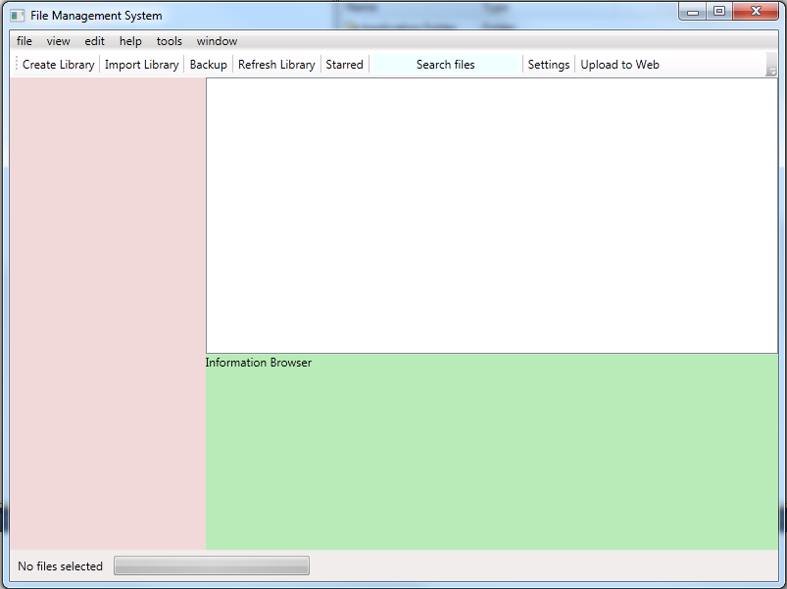
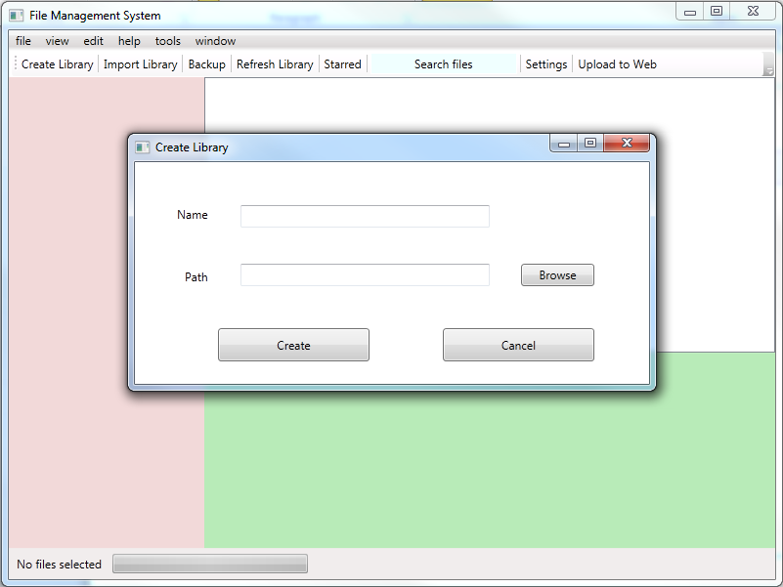

SECQURITY MEASURES:
- Files can be hidden from certain user by providing password.
- File passwords are saved using Encryption

LIMITATION OF THE PROJECT:
- This software works only for Windows XP & Windows 7.
- It consumes extra space for saving required information.

Any Client/Industry:

E-Komfort Zone
Bamangachi Station Road,
P.O: Bamangachi, P.S: Barasat,
Dist: North 24 Pgs
West Bengal- 743706

Future Scope and Further enhancement of the project:

- To support UNIX / Linux Based file systems.
- To Support Mobile File systems for Symbian, Meego & Android.

----------------------------- Thank You-------------------------

